Spotlight on Black History

Adult Non-Fiction & Biography

An African American and Latinx History of the United States
by Paul Ortiz
Non-Fiction, 305.800973

Black History for Beginners
by Denise Dennis
Non-Fiction, 305.896073 D423B

The African Americans: Many Rivers to Cross
by Henry Louis Gates
Non-Fiction, 305.896073 G223A

And Still I Rise: Black America Since MLK: An Illustrated Chronology
by Henry Louis Gates
Non-Fiction, 305.896073 G223AN

The Making of Black Lives Matter: A Brief History of an Idea  by Christopher J. Lebron  New Non-Fiction, 305.896073 L493M  Smoketown: The Untold Story of the Other Great Black Renaissance  by Mark Whitaker  Non-Fiction, 305.896073 | 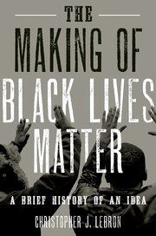

The Heritage: Black Athletes, a Divided America, and the Politics of Patriotism
by Howard Bryant
New Non-Fiction, 306.483
Let Freedom Ring: Stanley Tretick's Iconic Images of the March on Washington
by Kitty Kelley
Non-Fiction, 323.1196073 K287L

At the Dark End of the Street: Black Women, Rape, and Resistance--A New History of the Civil Rights Movement
by Danielle L. McGuire
Non-Fiction, 323.1196073 M179A

NAACP: Celebrating a Century: 100 Years in Pictures
Non-Fiction, 323.1196073 N11
Eyes on the Prize: America's Civil Rights Years, 1954-1965  by Juan Williams  Non-Fiction, 323.1196073 W673E  This Day in Civil Rights History | 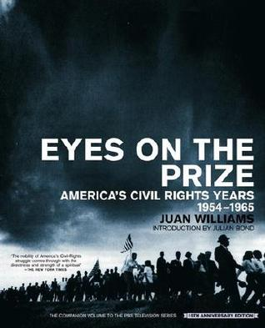
by Randall Williams
Non-Fiction, 323.1196073 W675T

Representing the Race: The Creation of the Civil Rights Lawyer
by Kenneth Walter Mack
Non-Fiction, 340 M19R

Buffalo Soldiers: African American Troops in the US Forces, 1866-1945
by Ron Field
Non-Fiction, 355.308996 F458B

Fighting for Freedom: Photographs from the National Museum of African American History and Culture
by National Museum of African American History and Culture
Non-Fiction, 355.008996

Fighting for Uncle Sam: Buffalo Soldiers in the Frontier Army
by John P. Langellier
Adult Non-Fiction, 355.008996 L261F

Death of Innocence: The Story of the Hate Crime That Changed America
by Mamie Till-Mobley
Non-Fiction, 364.134 T46D

The Blood of Emmett Till  by Timothy B. Tyson  Non-Fiction, 364.134 T988B  The Lost Education of Horace Tate: Uncovering the Hidden Heroes Who Fought for Justice in Schools | 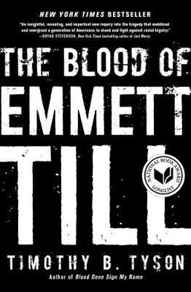
by Vanessa Siddle Walker
New Non-Fiction, 370.92
A Forgotten Sisterhood: Pioneering Black Women Educators and Activists in the Jim Crow South  by Audrey T. McCluskey  Non-Fiction, 370.922 M132F | 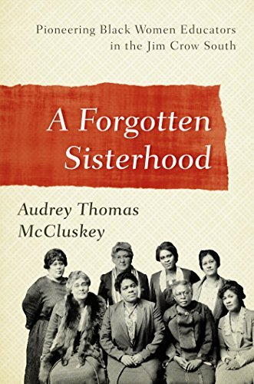
Hidden Figures: The American Dream and the Untold Story of the Black Women Mathematicians Who Helped Win the Space Race
by Margot Lee Shetterly
Non-Fiction, 510.9252 L515H

The Immortal Life of Henrietta Lacks
by Rebecca Skloot
Non-Fiction, 616.02774 SK45I

The Chitlin' Circuit: And the Road to Rock 'n' Roll
by Preston Lauterbach
Non-Fiction, 781.65 L377C

The African-American Century: How Black Americans Have Shaped Our Country
by Henry Louis Gates
Non-Fiction, 920.009296 G223A

The Black Calhouns: From Civil War to Civil Rights, with One African American Family
by Gail Lumet Buckley
Non-Fiction, 929.20973 B856B

The African American Experience during World War II
by Neil A. Wynn
Non-Fiction, 940.53089 W992A

Another America: The Story of Liberia and the Former Slaves Who Ruled It  by James Climent  Non-Fiction, 966.62 C49A  100 Amazing Facts about the Negro | 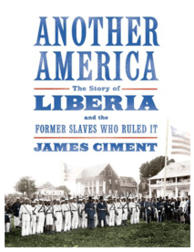
by Henry Louis Gates
Non-Fiction, 973.0496 G223O

Defining Moments in Black History: Reading Between the Lies
by Dick Gregory
New Non-Fiction, 973.0496 G862D

The Handy African American History Answer Book
by Jessie Carney Smith
Non-Fiction, 973.0496 SM61H

The Original Black Elite: Daniel Murray and the Story of a Forgotten Era
by Elizabeth Dowling Taylor
Non-Fiction, 973.0496 T213O

Black Fortunes: The Story of the First Six African Americans Who Escaped Slavery and Became Millionaires
by Shomari Wills
Non-Fiction, 973.0496

The Hemingses of Monticello: An American Family
by Annette Gordon-Reed
Non-Fiction, 973.46 G658H

The Slaves' War: The Civil War in the Words of Former Slaves
by Andrew Ward
Non-Fiction, 973.711 W21S

The Butler: A Witness to History
by Wil Haygood
Non-Fiction, 973.92 H331B

The Black History of the White House  by Clarence Lusane  Non-Fiction, 975.3 L975B  Indiana Blacks in the Twentieth Century  by Emma Lou Thornbrough | 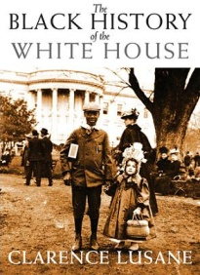
Non-Fiction, 977.2 T393I

Autobiographies
by Frederick Douglass
Biography, DOUGLASS

W. E. B. Du Bois
by David L. Lewis
Biography, DU BOIS, W. E. B.

Prince of Darkness: The Untold Story of Jeremiah G. Hamilton, Wall Street's First Black Millionaire
by Shane White
Biography, HAMILTON
Florynce "Flo" Kennedy: The Life of a Black Feminist Radical
by Sherie M. Randolph
Biography, KENNEDY

When They Call You a Terrorist: A Black Lives Matter Memoir
by Patrisse Khan-Cullors
Biography, KHAN-CULLORS

The Autobiography of Martin Luther King, Jr.
by Martin Luther King, Jr.
Biography, KING  My Life, My Love, My Legacy  by Coretta Scott King  Biography, KING  Showdown: Thurgood Marshall and the Supreme Court Nomination That Changed America | 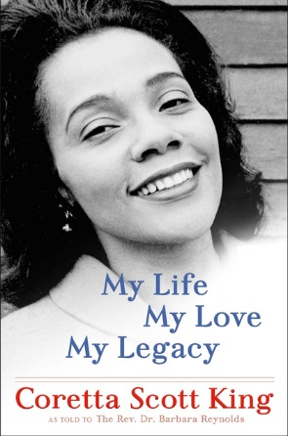
by Will Haygood
Biography, MARSHALL

Jane Crow: The Life of Pauli Murray
by Rosalind Rosenberg
Biography, MURRAY

Solomon Northup: The Complete Story of the Author of Twelve Years a Slave
by David Fiske
Biography, NORTHUP

A Consequential President: The Legacy of Barack Obama
by Michael D’Antonio
Biography, OBAMA

The Rebellious Life of Mrs. Rosa Parks  by Jeanne Theoharis  Biography, PARKS  Soldier: The Life of Colin Powell  by Karen DeYoung  Biography, POWELL | 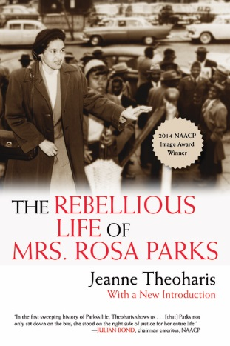
Be Free or Die: The Amazing Story of Robert Smalls' Escape from Slavery to Union Hero
by Cate Lineberry
Biography, SMALLS

Enduring Truths: Sojourner's Shadows and Substance
by Darcy Grimaldo Grigsby
Biography, TRUTH

Harriet Tubman: The Road to Freedom
by Catherine Clinton
Biography, TUBMAN

Up from History: The Life of Booker T. Washington
by Robert J. Norrell
Adult Biography, WASHINGTON, BOOKER T.

The Autobiography of Malcolm X
by Malcolm X and Alex Haley
Adult Biography, X, MALCOLM

Juvenile Non-Fiction & Biography

Heroes for Civil Rights
by David A. Adler
Juvenile Non-Fiction, 323.092 AD59H

Remember: The Journey to School Integration
by Toni Morrison
Juvenile Non-Fiction, 379.263 M834R

Black Hoops: The History of African-Americans in Basketball
by Fredrick McKissack
Juvenile Non-Fiction, 796.323 M217B

The Great Migration: Journey to the North  by Eloise Greenfield  Juvenile Non-Fiction, 811.54 G837G  Pathfinders: The Journeys of 16 Extraordinary Black Souls  by Tonya Bolden | 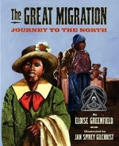
J Non-Fiction, 920.009296

Harlem Hellfighters
by J. Patrick Lewis
Juvenile Non-Fiction, 940.5403 L587H

The Tuskegee Airmen
by Sarah De Capua
Juvenile Non-Fiction, 940.544973 D355T

Ain't Nothing but a Man: My Quest to Find the Real John Henry
by Scott Reynolds Nelson
Juvenile Non-Fiction, 973.0496 N337A

Hand in Hand: Ten Black Men Who Changed America
by Andrea Davis Pinkney
Juvenile Non-Fiction, 973.0496 P656H

Discovering Black America: From the Age of Exploration to the Twenty-First Century
by Linda Tarrant-Reid
Juvenile Non-Fiction, 973.0496 T176D

Answering the Cry for Freedom: Stories of African Americans and the American Revolution  by Gretchen Woelfle  Juvenile Non-Fiction, 973.0496 W82A | 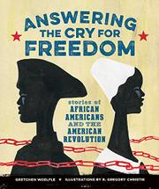
Searching for Sarah Rector: The Richest Black Girl in America
by Tonya Bolden
Juvenile Non-Fiction, 976.684 B637S

Claudette Colvin: Twice Toward Justice
By Phillip M. Hoose
Juvenile Biography, COLVIN, CLAUDETTE

Unbound and Unbroken: The Story of Frederick Douglass
By Amos Esty
Juvenile Biography, DOUGLASS, FREDERICK

W.E.B. Du Bois: Civil Rights Activist, Author, Historian
By Jim Whiting
Juvenile Biography, DU BOIS, W.E.B.

Medgar Evers and the NAACP
By Gary Jeffrey
Juvenile Biography, EVERS, MEDGAR

Martin Luther King, Jr.: Civil Rights Leader
By Robert E. Jakoubek
Juvenile Biography, KING, MARTIN LUTHER

The Amazing Age of John Roy Lynch  By Chris Barton  Juvenile Biography, LYNCH, JOHN ROY  I Am Rosa Parks  By Brad Meltzer  Juvenile Biography, PARKS, ROSA | 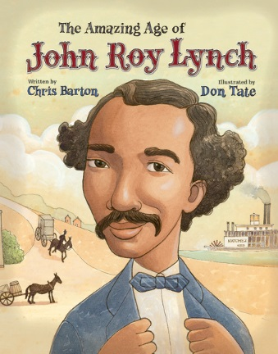
Nat Turner: Slave Revolt Leader
By Terry Bisson
Juvenile Biography, TURNER, NAT

Booker T. Washington: Leader and Educator
By Patricia C. McKissack
Juvenile Biography, WASHINGTON, BOOKER T.

Ida B. Wells-Barnett
By Heidi Moore
Juvenile Biography, WELLS-BARNETT

Malcolm X: I Believe in the Brotherhood of Man, All Men
By Jeff Burlingame
Juvenile Biography, X, MALCOLM

