African Americans in Literature

Americanah
by Chimamanda Ngozi Adichie
Fiction, ADICHIE, CHIMAMANDA NGOZI

The Light of the World
by Elizabeth Alexander
Biography, ALEXANDER, ELIZABETH

The Complete Collected Poems of Maya Angelou
by Maya Angelou
Non-Fiction, 811.54 AN43C

Maya Angelou: And Still I Rise
Non-Fiction DVDs, B ANGELOU

Collected Essays
by James Baldwin
Non-Fiction, 814.54 B193C

Go Tell It on the Mountain
by James Baldwin
Fiction, BALDWIN, JAMES

The Sellout
By Paul Beatty
Fiction, BEATTY, PAUL

The Mothers
by Brit Bennett
Fiction, BENNETT, BRIT

Ruby  By Cynthia Bond  Fiction, BOND, CYNTHIA  The Essential Gwendolyn Brooks  by Gwendolyn Brooks  Non-Fiction, 811.54 B791E | 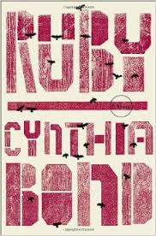

William Wells Brown: An African American Life
by Ezra Greenspan
Biography, BROWN, WILLIAM WELLS
Solemn
by Kalisha Buckhanon
Fiction, BUCKHANON, KALISHA

Kindred
by Octavia E. Butler
Science Fiction, BUTLER, OCTAVIA E.

The Emperor of Ocean Park
by Stephen L. Carter
Fiction, CARTER, STEPHEN

Angels Make Their Hope Here
By Breena Clarke
Fiction, CLARKE, BREENA

What We Lose
by Zinzi Clemmons
Fiction, CLEMMONS, ZINZI

Bud, Not Buddy
by Christopher Paul Curtis
Juvenile Fiction, CURTIS, CHRISTOPHER PAUL

Autobiographies
by Frederick Douglass
Biography, DOUGLASS, FREDERICK

Collected Poems, 1974-2004
by Rita Dove
Non-Fiction, 811.54 D751C

The Souls of Black Folk
by W. E. B. Du Bois
Non-Fiction, 973.0496 D852S

Writings
by W. E. B. Du Bois
Non-Fiction, 973.0496 D852W

W.E.B. DuBois: The Fight for Equality and the American Century 1919-1963
by David L. Lewis
Biography, DU BOIS, W. E. B.

The Girl Who Fell from the Sky  by Heidi W. Durrow  Fiction, DURROW, HEIDI  Well-Read Black Girl: Finding Our Stories, Discovering Ourselves: An Anthology  by Glory Edim | 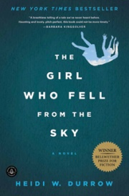
New Non-Fiction, 810.9896 W458

Invisible Man
by Ralph Ellison
Fiction, ELLISON, RALPH

Juneteenth
by Ralph Ellison
Fiction, ELLISON, RALPH

The Autobiography of Miss Jane Pittman
by Ernest J. Gaines
Fiction, GAINES, ERNEST J.

A Lesson before Dying  by Ernest J. Gaines  Fiction, GAINES, ERNEST J.  The Annotated African American Folktales  by Henry Louis Gates  Non-Fiction, 398.208996 AN78 | 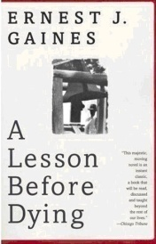
Difficult Women
by Roxane Gay
Fiction, GAY, ROXANE

The Collected Poetry of Nikki Giovanni, 1968-1998
by Nikki Giovanni
Non-Fiction, 811.54 G439C

The Wide Circumference of Love
by Marita Golden
Fiction, GOLDEN, MARITA

The Spook Who Sat by the Door
by Sam Greenlee
Fiction, GREENLEE, SAM

One Last Word: Wisdom from the Harlem Renaissance
by Nikki Grimes
Juvenile Non-Fiction, 811.54 G882O

Homegoing
by Yaa Gyasi
Fiction, GYASI, YAA

Alex Haley and the Books That Changed a Nation
by Robert J. Norrell
Biography, HALEY, ALEX

A Raisin in the Sun
by Lorraine Hansberry
Non-Fiction, 812.54 H198R

Looking for Lorraine: The Radiant and Radical Life of Lorraine Hansberry
by Imani Perry
New Biography, HANSBERRY

Harlem Renaissance: Five Novels of the 1920s
Fiction, HARLEM

Harlem Renaissance: Four Novels of the 1930s
Fiction, HARLEM
My Soul Looks Back
by Jessica B. Harris
Biography, HARRIS, JESSICA B.

Someone Knows My Name
by Lawrence Hill
Fiction, HILL, LAWRENCE

Cotton Comes to Harlem
by Chester B. Himes
Fiction, HIMES, CHESTER

The Selected Letters of Langston Hughes
by Langston Hughes
Non-Fiction, 816.52 H874S

The Weary Blues
By Langston Hughes
Non-Fiction, 811.52 H874W

Their Eyes Were Watching God  by Zora Neale Hurston  Fiction, HURSTON, ZORA NEALE  Novels and Stories  by Zora Neale Hurston  Fiction, HURSTON, ZORA NEALE | 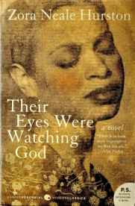

Wrapped in Rainbows: The Life of Zora Neale Hurston
by Valerie Boyd
Biography, HURSTON, ZORA NEALE

I Was Born a Slave: An Anthology of Classic Slave Narratives
Non-Fiction, 920.009296 I1

Dark Rain: New Orleans Story
by Mat Johnson
Graphic Novels, JOHNSON, MAT

The Known World
by Edward P. Jones
Fiction, JONES, EDWARD P.

An American Marriage: A Novel
by Tayari Jones
Fiction, JONES

Passage
by Khary Lazarre-White
Fiction, LAZARRE-WHITE

To Be a Slave
by Julius Lester
Juvenile Non-Fiction, 306.362 L567T 1998

Bluebird, Bluebird
by Attica Locke
Fiction, LOCKE

The Twelve Tribes of Hattie
by Ayana Mathis
Fiction, MATHIS, AYANA

The Good Lord Bird  by James McBride  Fiction, MCBRIDE, JAMES  The Book of Harlan  by Bernice L. McFadden  Fiction, MCFADDEN, BERNICE L. | 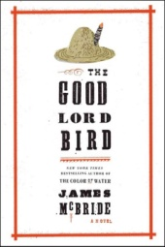
How Stella Got Her Groove Back
by Terry McMillan
Fiction, MCMILLAN, TERRY

Waiting to Exhale
by Terry McMillan
Fiction, MCMILLAN, TERRY

The Supremes at Earl's All-You-Can-Eat
by Edward Kelsey Moore
Fiction, MOORE, EDWARD KELSEY

Beloved  by Toni Morrison  Fiction, MORRISON, TONI  The Bluest Eye  by Toni Morrison  Fiction, MORRISON, TONI  Song of Solomon  by Toni Morrison | 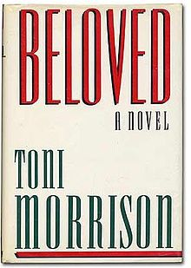
Fiction, MORRISON, TONI

Devil in a Blue Dress
by Walter Mosley
Mystery, MOSLEY, WALTER

The Women of Brewster Place
by Gloria Naylor
Fiction, NAYLOR, GLORIA

12 Years a Slave  by Solomon Northup  Biography, NORTHUP, SOLOMON  The Norton Anthology of African American Literature  Non-Fiction, 810.80896 N821 | 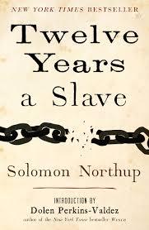

Of Poetry & Protest: From Emmett Till to Trayvon Martin
Non-Fiction, 811.008 OF1

Balm
by Dolen Perkins-Valdez
Axis 360 eBook

Preaching with Sacred Fire: An Anthology of African American Sermons, 1750 to the Present
Non-Fiction, 252.008996 P91

New and Collected Poems, 1964-2006
by Ishmael Reed
Non-Fiction, 811.54 R251N 2006

The Plays
by Ishmael Reed
Non-Fiction, 812.54 R251P

Push
by Sapphire
Fiction, SAPPHIRE

A Kind of Freedom
by Margaret Wilkerson Sexton
Fiction, SEXTON, MARGARET WILKERSON

For Colored Girls Who Have Considered Suicide/When the Rainbow is Enuf  by Ntozake Shange  Non-Fiction, 811.54 SH18F  Forty Acres  by Dwayne Alexander Smith | 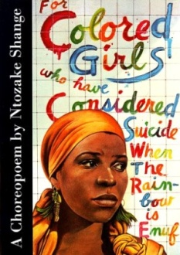
Fiction, SMITH, DWAYNE ALEXANDER

Citizens Creek
by Lalita Tademy
Fiction, TADEMY, LALITA

Red River  by Lalita Tademy  Fiction, TADEMY, LALITA  Roll of Thunder, Hear My Cry  by Mildred D. Taylor  Juvenile Fiction, TAYLOR, MILDRED D. | 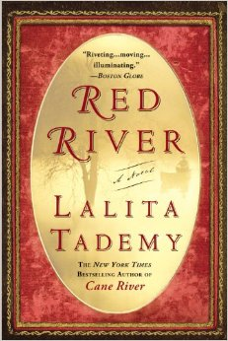

The Color Purple
by Alice Walker
Fiction, WALKER, ALICE

Jubilee
by Margaret Walker
Fiction, WALKER, MARGARET

Salvage the Bones
by Jesmyn Ward
Fiction, WARD, JESMYN

No One is Coming to Save Us
by Stephanie Powell Watts
Fiction, WATTS, STEPHANIE POWELL

The Wedding
by Dorothy West
Fiction, WEST, DOROTHY

The Underground Railroad
by Colson Whitehead
Fiction, WHITEHEAD, COLSON

Another Brookyn
by Jacqueline Woodson
Fiction, WOODSON, JACQUELINE

Black Boy: American Hunger: A Record of Childhood and Youth
by Richard Wright
Biography, WRIGHT, RICHARD

Early Works  by Richard Wright  Fiction, WRIGHT, RICHARD  Native Son  by Richard Wright  Fiction, WRIGHT, RICHARD  Book of Hours  by Kevin Young  Non-Fiction, 811.54 Y85BO | 