African Americans in Arts & Entertainment

Art

Fired Up! Ready to Go!: Finding Beauty, Demanding Equity: An African American Life in Art: The Collections of Peggy Cooper Cafritz
by Peggy Cooper Cafritz
Non-Fiction, 704.0396

Miles Davis: The Collected Artwork  by Scott Gutterman  Non-Fiction, 759.13 D295M  Over the Line: The Art and Life of Jacob Lawrence | 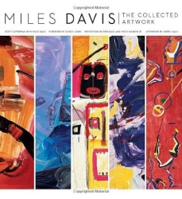
by Peter T. Nesbett
Non-Fiction, 759.13 L432O

Collecting African American Art: Works on Paper and Canvas
by Halima Taha
Non-Fiction, 760.8996 T13C

Bluff City: The Secret Life of Photographer Ernest Winters
by Preston Lauterbach
Biography, WITHERS, ERNEST

Basquiat: Rage to Riches
Non-Fiction DVDs, B BASQUIAT

Etched in Clay: The Life of Dave, Enslaved Potter and Poet
by Andrea Cheng
Juvenile Non-Fiction, 738.092 C421E

Radiant Child: The Story of Young Artist Jean-Michel Basquiat
by Javaka Steptoe
Picture Books, STEPTOE

Draw What You See: The Life and Art of Benny Andrews
by Kathleen Benson
Picture Books, BENSON

Music

Smoketown: The Untold Story of the Other Great Black Renaissance
by Mark Whitaker
Non-Fiction, 305.896073

The Chitlin' Circuit: And the Road to Rock 'n' Roll
by Preston Lauterbach
Non-Fiction, 781.65 L377C

The Most Beautiful: My Life with Prince
by Mayte Garcia
Non-Fiction, 782.42164

Dig If You Will the Picture: Funk, Sex, God, and Genius in the Music of Prince
by Ben Greenman
Non-Fiction, 782.42164

Better than Alright: Finding Peace, Love & Power
by Ledisi
Non-Fiction, 782.421644 L499B

Ain't Too Proud to Beg: The Troubled Lives and Enduring Soul of the Temptations
by Mark Ribowsky
Non-Fiction, 782.421644 R357A

Ice: A Memoir of Gangster Life and Redemption
by Ice-T
Non-Fiction, 782.421649 IC2I

Queen Bey: The Celebration of the Power and Creativity of Beyonce Knowles-Carter
by Veronica Chambers
Non-Fiction, 782.42164

Soul Train: The Music, Dance, and Style of a Generation  by Questlove  Non-Fiction, 791.456578 T371S  The Life of James Brown | 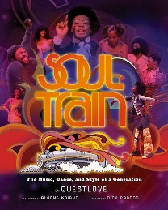
by Geoff Brown
Biography, BROWN

The Book of Luke: My Fight for Truth, Justice and Liberty City
by Luther Campbell
Biography, CAMPBELL

Music is My Mistress
by Duke Ellington
Biography, ELLINGTON

Marvin Gaye, My Brother
by Frankie Gaye
Biography, GAYE

Soul Survivor: A Biography of Al Green
by Jimmy McDonough
Biography, GREEN

Sing for Your Life: A Story of Race, Music, and Family
by Daniel Bergner
Biography, GREEN

Herbie Hancock: Possibilities
by Herbie Hancock
Biography, HANCOCK

Raw: My Journey into the Wu-Tang
by Lamont "U-God" Hawkins
Biography, HAWKINS

Roland Hayes: The Legacy of an American Tenor
by Christopher A. Brooks
Biography, HAYES

Lightnin' Hopkins: His Life and Blues
by Alan B. Govenar
Biography, HOPKINS

A Woman Like Me
by Bettye LaVette
Biography, LAVETTE

The Autobiography of Gucci Mane
by Gucci Mane
Biography, MANE

Traveling Soul: The Life of Curtis Mayfield
by Todd Mayfield
Biography, MAYFIELD

The Art & Science of Respect: A Memoir
by James Prince
Biography, PRINCE

Otis Redding: An Unfinished Life
by Jonathan Gould
Biography, REDDING

Nina Simone: The Biography
by David Brun-Lambert
Biography, SIMONE

Strayhorn: An Illustrated Life
Biography, STRAYHORN

Queen of Bebop: The Musical Lives of Sarah Vaughan
By Elaine M. Hayes
Biography, VAUGHAN

My Life as I See It: An Autobiography
by Dionne Warwick
Biography, WARWICK

In Search of Pharrell Williams
by Paul Lester
Biography, WILLIAMS

Nat King Cole  by Daniel Mark Epstein  Large Print Biography, B COLE  Prince: The Man, the Symbol, the Music  by Eric Braun  Axis 360 eBook | 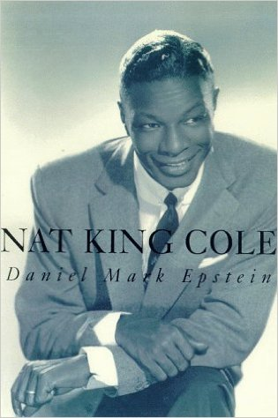

Bessie
Feature Film DVDs, BESSIE

Ray
Feature Film DVDs, RAY

American Hip-Hop: Rappers, DJs, and Hard Beats
by Nathan Sacks
YA Non-Fiction, 782.421649 SA14A

The Jacksons Legacy
by Fred Bronson
Juvenile Non-Fiction, 782.421644

OutKast
by Greg Roza
Juvenile Non-Fiction, 782.421649 R817O

Marian Anderson: A Voice Uplifted  by Victoria Garrett Jones  Juvenile Biography, ANDERSON  Louis Armstrong: Musician | 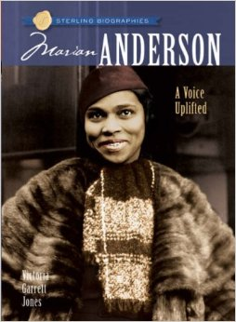
by Kenneth Partridge
Juvenile Biography, ARMSTRONG

Ella Fitzgerald: First Lady of Jazz
by Megan Schoeneberger
Juvenile Biography, FITZGERALD

Billie Holiday: Singer
by Forrest Cole
Juvenile Biography, HOLIDAY

Pharrell Williams
by Marie Morreale
Juvenile Biography, WILLIAMS

Stevie Wonder: Musician
by Jeremy K. Brown
Juvenile Biography, WONDER

Trombone Shorty
by Troy Andrews
Picture Books, ANDREWS

Benny Goodman & Teddy Wilson: Taking the Stage as the First Black-and-White Jazz Band in History  by Lesa Cline -Ransome | 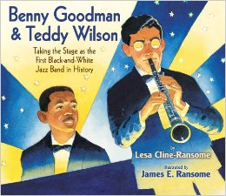
Picture Books, CLINE-RANSOME
Little Melba and Her Big Trombone
by Katheryn Russell-Brown
Picture Books, RUSSELL-BROWN

Stage & Screen

Black Comedians on Black Comedy: How African-Americans Taught Us to Laugh
by Darryl Littleton
Non-Fiction, 792.7028 L734B

The Awkward Thoughts of W. Kamau Bell
by W. Kamau Bell
Biography, BELL

Unsuccessful Thug: One Comedian's Journey from Naptown to Tinseltown
by Mike Epps
Biography, EPPS

Blessed Life: My Surprising Journey of Joy, Tears, and Tales from Harlem to Hollywood
by Kim Fields
Biography, FIELDS

Every Day I'm Hustling
by Vivica A. Fox
Biography, FOX

Black and Blue: The Redd Foxx Story
by Michael Starr
Biography, FOXX

The Mother of Black Hollywood: A Memoir
By Jenifer Lewis
Biography, LEWIS

Failing Up: How to Take Risks, Aim Higher, and Never Stop Learning
by Leslie Odom
Biography, ODOM

The Misadventures of Awkward Black Girl
by Issa Rae
Biography, RAE

This Is Just My Face: Try Not to Stare
by Gabourey Sidibe
Biography, SIDIBE

Stand by Your Truth and Then Run for Your Life
by Rickey Smiley
Biography, SMILEY

We're Going to Need More Wine
by Gabrielle Union
Biography, UNION

Rabbit: The Autobiography of Ms. Pat
by Patricia Williams
Biography, WILLIAMS

Oprah: A Biography  by Kitty Kelley  Biography, WINFREY  Introducing Dorothy Dandridge  Feature Film DVDs, INTRODUCING | 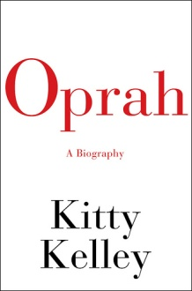
Chadwick Boseman
by Pete DiPrimio
Juvenile Biography, BOSEMAN

Jennifer Hudson
by Joanne Mattern
Juvenile Biography, HUDSON, JENNIFER

The Nutcracker in Harlem
by T. E. McMorrow
Picture Books, MCMORROW

